Assisment Details

Deliverables->

4 Micro-services created user,product,order,recommendation:
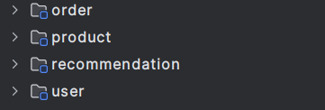

Code is deployed to git repo.

Postman collection is created and uploaded to repo:
Each file representing its respected service api collection
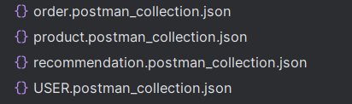

DATABASE->
3 schema is created connected with its respective services.
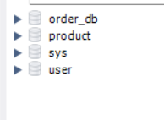

Schema.
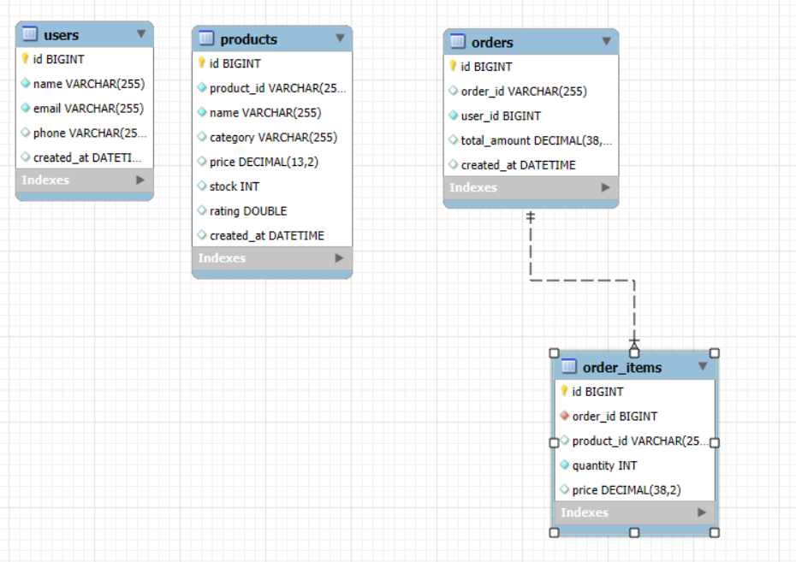

Deployments:
I have created my AWS account long ago and I my 1 year free tier is expired hence I have made deployment in docker engine.

I have deployed Database, User_service and kafka server in docker.

And my micro-services are accessing DB and Kafka through docker only.

Inter communication in docker container is successful by created a network inside docker and attaching these containers with that same network.

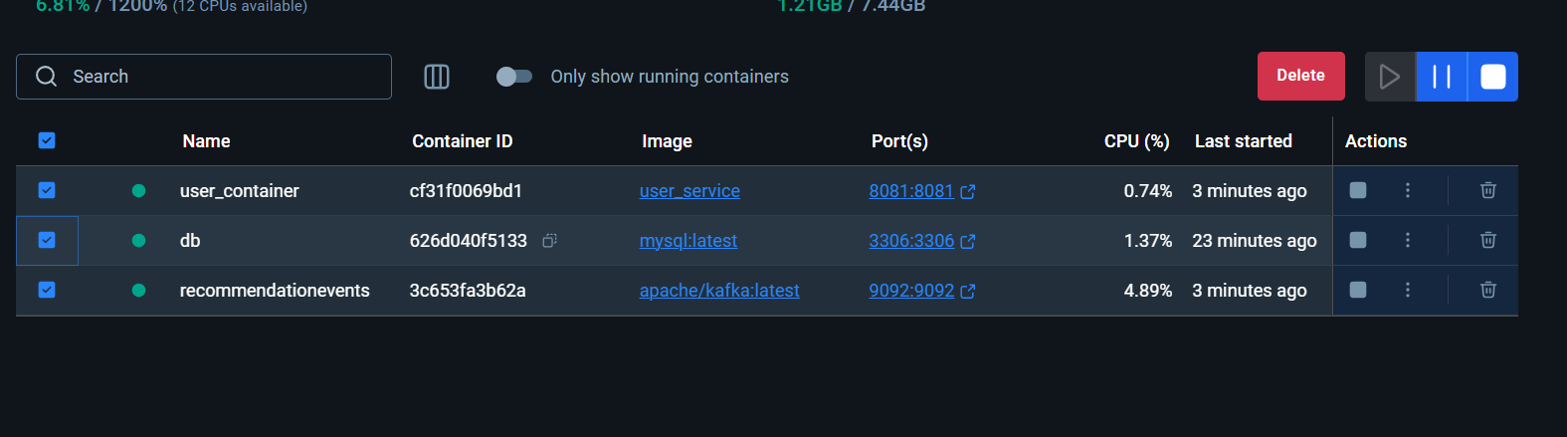

Testing scenarios:
Before making an order stock is 16
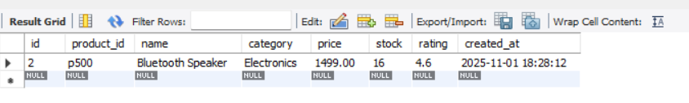

Order saved succesfully:
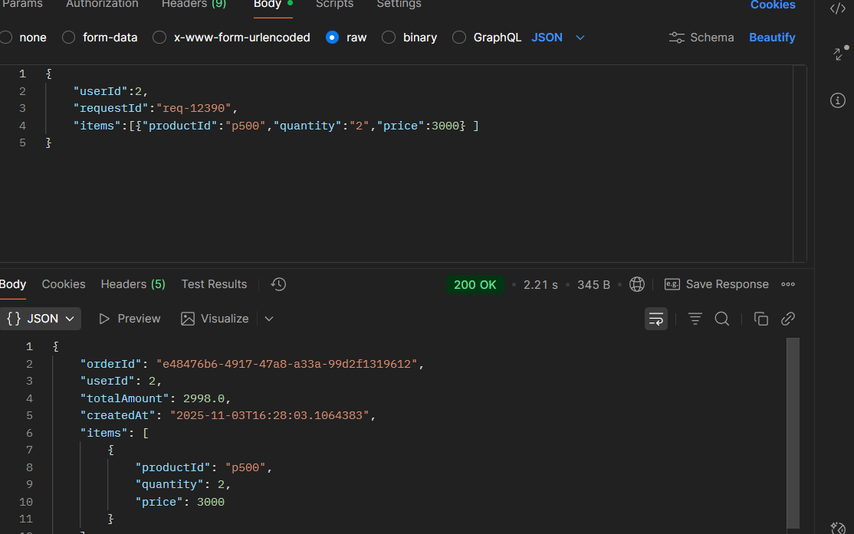

Stock reduced to 14

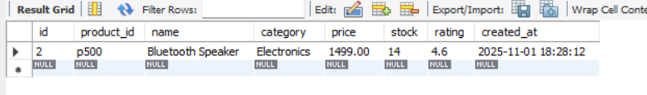
Orders saving in DB with the user id
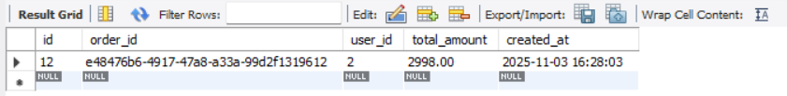

Recommendation service received the event but not processed because its not having sufficient data to recommend.

Exception handeling if user provide wrong email and similar reponse comes with invalid req.
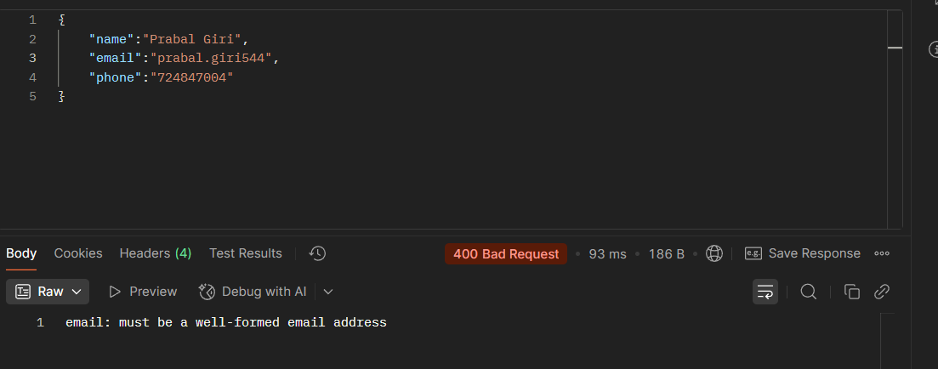

Adding multiple products so we can check the recommendation service properly

Products saving in product DB:

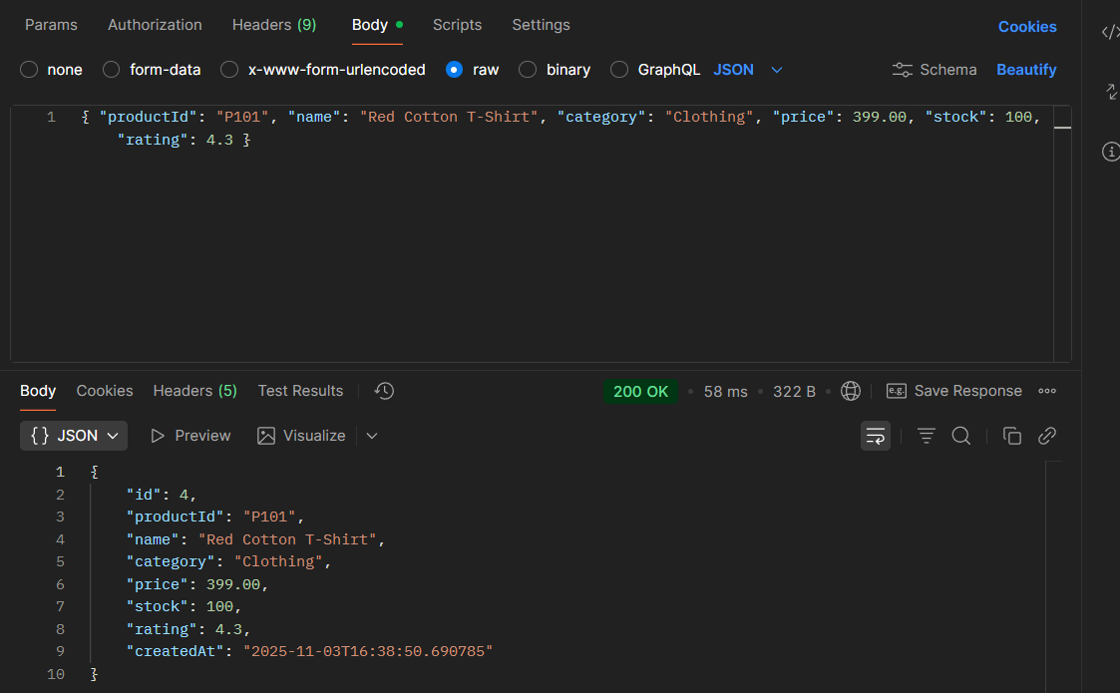

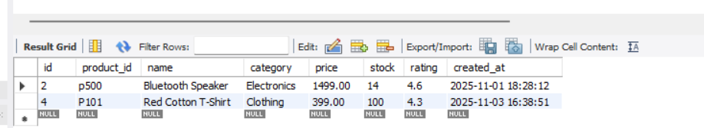

Able to filter the product as-well.
Fetching products by category.
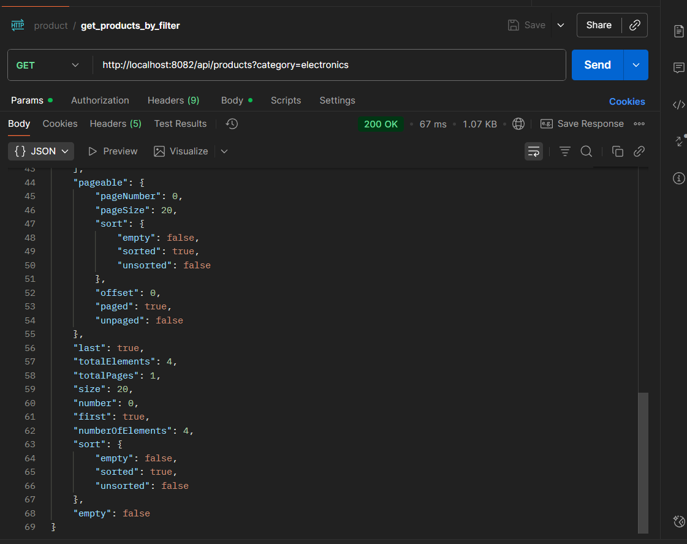

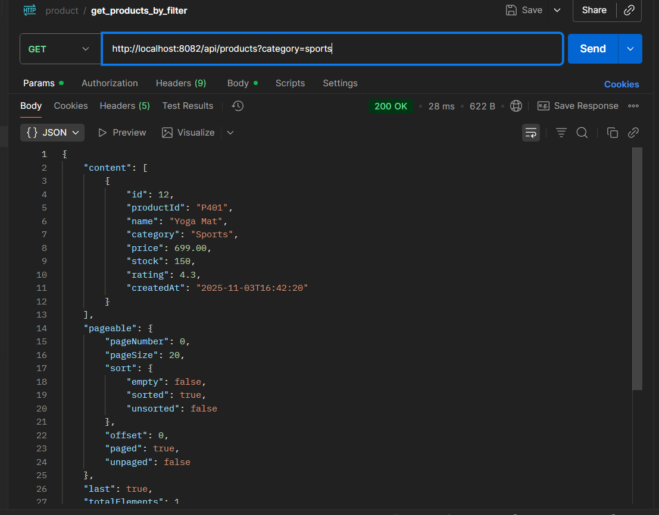

Making multiple orders.

Kafka server receiving events:
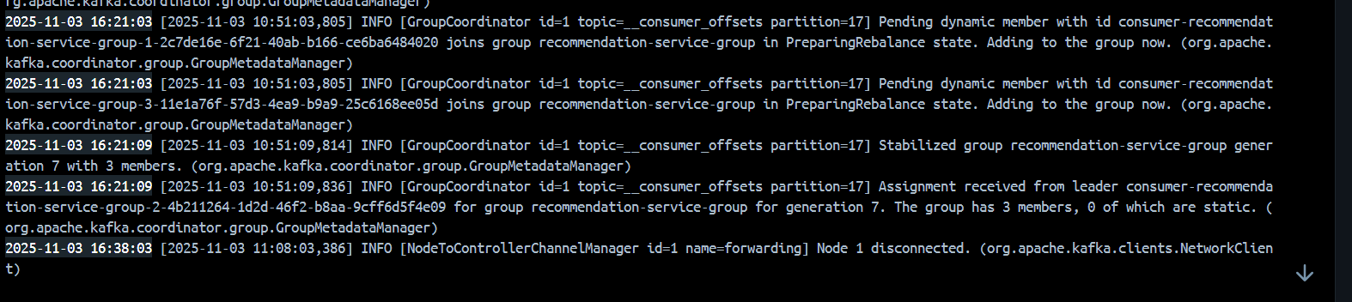

Same events consumed by recommendation service:
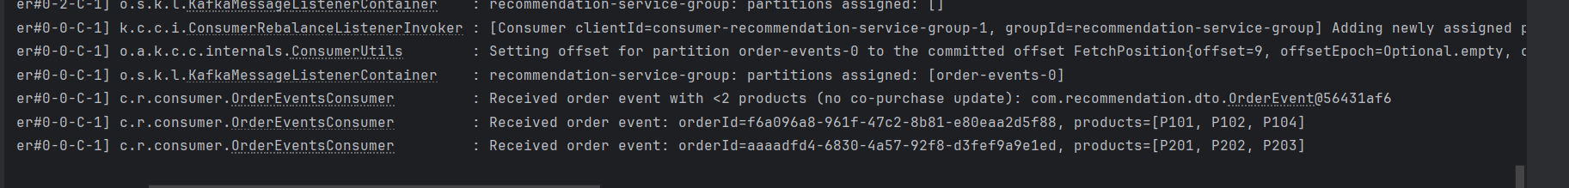

While user surfing through product with id P301->P304 & P303 was recommended.
